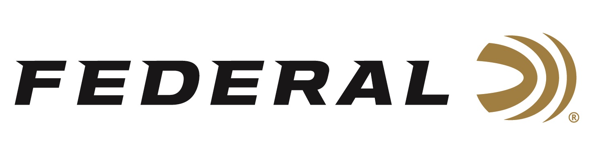

FOR IMMEDIATE RELEASE

**Hancock Wins Gold at ISSF World Cup Final in Italy**

**ANOKA, Minnesota –** **July 10, 2025 –** Federal Ammunition congratulates Vincent Hancock on his gold medal performance in Men’s Skeet at the ISSF World Cup Shotgun event in Lonato, Italy. This victory, his sixth gold medal earned at Lonato, brings his World Cup total up to 30 medals to go along with his four Olympic gold medals at only 36 years old. This was the first overseas competition for Hancock since winning the Olympic gold medal in Paris in 2024.

Hancock, ranked number one in the world, shot his way into the men’s skeet finals in the first position by missing just one target out of 125 during qualification. As the final round was about to begin, the weather conditions changed, and gusty winds picked up at the range. “There was nothing easy about that final,” said the 4-time Olympic gold medalist. “I definitely missed a lot more targets than I should have, some was the wind, and some was me but I’m thankful to be able to come out on top today,” stated Hancock.

Hancock persevered through the tough conditions and forced a shoot-off with Sweden’s Henrik Jannson in the final. The American prevailed in dramatic fashion as the Swedish shooter, ranked 90th in the world, had two opportunities to win gold with a clean pair after Hancock misses but couldn’t seize the moment. In the final stage, Hancock ran clean while the Swedish shooter missed the final target and the American claimed the gold medal at a venue he calls his favorite. “This is always the biggest World Cup event of the year and if you win the World Cup or World Championship in Lonato that means you’ve done something… this one means a lot to me,” says Hancock.

Up next for Hancock, he and his wife are expecting their third child, and he expects to be competing at the 2025 ISSF World Championships in Athens, Greece in October.

To support America’s shooting team, visit [www.usashooting.org](http://www.usashooting.org) to find out more.

Federal Ammunition products are available at dealers nationwide and online. For more information on all Federal products, visit [www.federalpremium.com](http://www.federalpremium.com).

**Press Release Contact:** JJ Reich

Senior Manager – Press Relations

E-mail: media@tkghunt.com

**About Federal Ammunition**

Federal, headquartered in Anoka, MN, is an ammunition brand of The Kinetic Group, owned by CSG, a globally diversified industrial group based in Prague (Czech Republic). From humble beginnings nestled among the lakes and woods of Minnesota, Federal Ammunition has evolved into one of the world's largest producers of sporting ammunition. In 1922, founding President Charles L. Horn paved the way for our success. Today, Federal carries on Horn's vision for quality products and services with the next generation of outdoorsmen and women. We maintain our position as experts in the science of ammunition production. Every day, Federal manufactures products to enhance our customers' shooting experience while partnering with the conservation organizations that protect and support our outdoor heritage. Federal offers thousands of options in our Federal Premium® and standard Federal® lines, which is what makes it the most complete ammunition company in the business and helps it provide customers with a choice no matter what the pursuit.